**GitHub Copilot request process**

**Guideline**

|  |  |  |
| --- | --- | --- |
| Version id | Date | Changes |
| Version – 1.0 | 31-Oct-2023 | First draft |
| Version – 1.1 | 1-Nov-2023 | Added the GitHub Copilot License fee details |
| Version – 1.2 | 2-Nov-2023 | Changed the approval email subject in Step-1. |
| Version – 1.3 | 8-Nov-2023 | Added Legal Team Guidelines Section. |
| Version- 1.4 | 11-Dec-2023 | Updated the Service line approver details |
| Version- 1.5 | 5-Jan-2024 | Added Queries through Live support GSD Section |

Contents

GithubCopilot Servicenow request process 3

3 Step Process to get GitHub Copilot 3

**Step 1- Approval Mail template** 4

**Step 2: ServiceNow Request** 5

**Step 3 : Activate** **GitHub Copilot** 6

**GitHub Copilot License fee** 8

**Queries through Live Support GSD** 9

**Legal Team - Guidelines** 10

**Training Video links** 11

# GithubCopilot Servicenow request process

## 3 Step Process to get GitHub Copilot

* Step 1 – Obtain approval from your respective Service Line POC
* Refer below for the mail template and Approver Contacts for the respective Service Line.
* Step 2 – Raise ServiceNow request.
* Step 3- Activate GitHub Copilot.

## **Step 1- Approval Mail template**

Use the attached mail template below to get approval from your respective service line POC and attach it as part of your ServiceNow request.



**Service Line and Respective Approvers**

|  |  |  |
| --- | --- | --- |
| **#** | **Service Line** | **Approver** |
| **1** | ADM | Chinnaswamy, Amudha (102681)  Chidambaram, Subramaniam (107557)  Patwardhan, Shashank (497763) |
| **2** | QEA | Shridhar, Bhat (117372) |
| **3** | Others | * Academy – M, Kandaswamy. (155213) * EPS - Muthulingam, Mohanapriya (207458) & Bhowmik, Subhendu (105774) * BMP-Wildes, John (914239) * SPEG- T K, Narayanan (194123) * MBG- Wildes, John (914239) * MDU - Krishnaswamy Narayanan, Krishma (584586) * IoT- Geevar, Jeen (114023) * GSA-Cook, Andrew (885327) & Chopade, Sudhir (910112) |
| **4** | AIA | Radhakrishnan, Rimna (112791)  John, Anil (487063) |
| **5** | DE | Raychaudhuri, Sankha (113751) |
| **6** | CIS | Umakantham, Rajkumar (323777)  S, Ganesh (107502) |
| **7** | DX | Raychaudhuri, Sankha (113751) |
| **8** | TriZetto | Marfatia, Amber (486361) |
| **9** | IT | Sunilkumar, P (292184) |
| **10** | ISG | Krishnaswamy Narayanan, Krishma (584586) |

## **Step 2: ServiceNow Request**

1. Login into Service now

[**https://ctsccprod.service-now.com/ss?id=ss_home_page_servicenow**](https://ctsccprod.service-now.com/ss?id=ss_home_page_servicenow)

Search as “Request Software asset”

1. Fill all the mandatory fields and ensure the **below 3 fields** are filled in appropriately.
2. Software model 🡪Search as *\*GitHub Copilot*.
3. Business Justification 🡪 Enter your Service Line you are part of e.g., ADM/QEA/AIA/IT.
4. Add Attachments 🡪 Attach Approval email from the respective Service Line approvers. Refer to the above table for Service Line approvers.

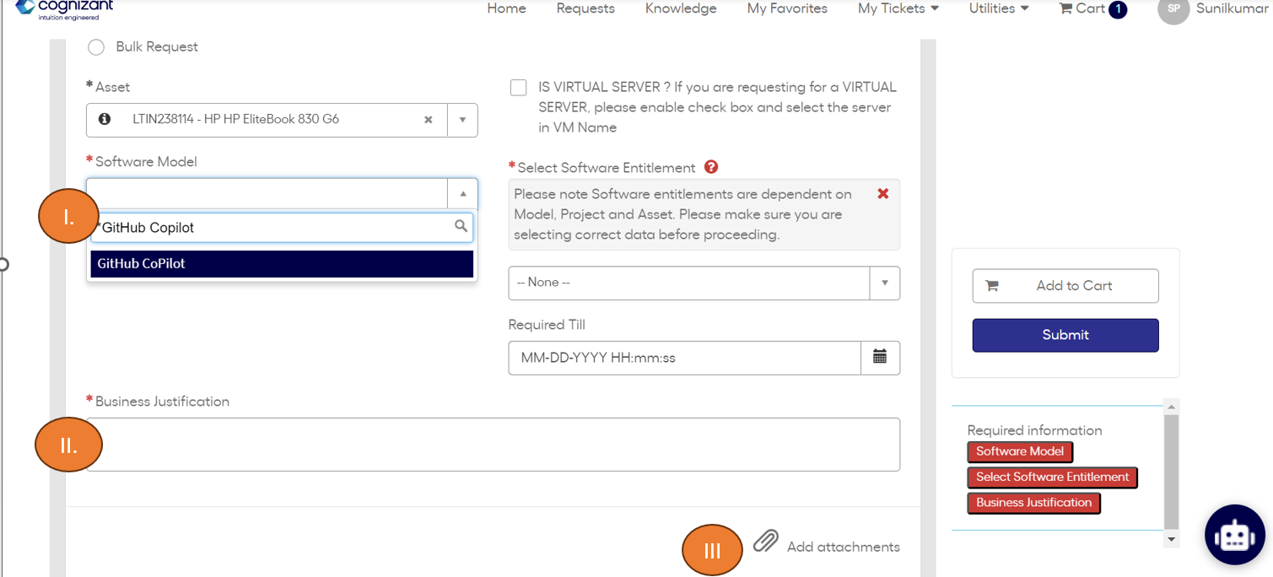

Once the request is raised and approved by PM, IT will take 1 business day (24 hours) to fulfill the request.

## **Step 3 : Activate** **GitHub Copilot**

1. Login into the Url [https://github.com/enterprises/CognizantGitHubCopilot](https://github.com/enterprises/CognizantGitHubCoPilot)

Once access has been granted, you will see the above screen with “continue” button.

**2**: Click on Continue

You will be redirect to the below screen.

**3**: Open Visual Studio Enterprise/Professional or VS Code and make sure GitHub is connected with your Cognizant AssociateId to enable the Copilot license. Please avoid connecting GitHub with your personal or any other email IDs.

Refer the supported IDE for Copilot - [Configuring GitHub Copilot in your environment - GitHub Docs](https://docs.github.com/en/copilot/configuring-github-copilot/configuring-github-copilot-in-your-environment)

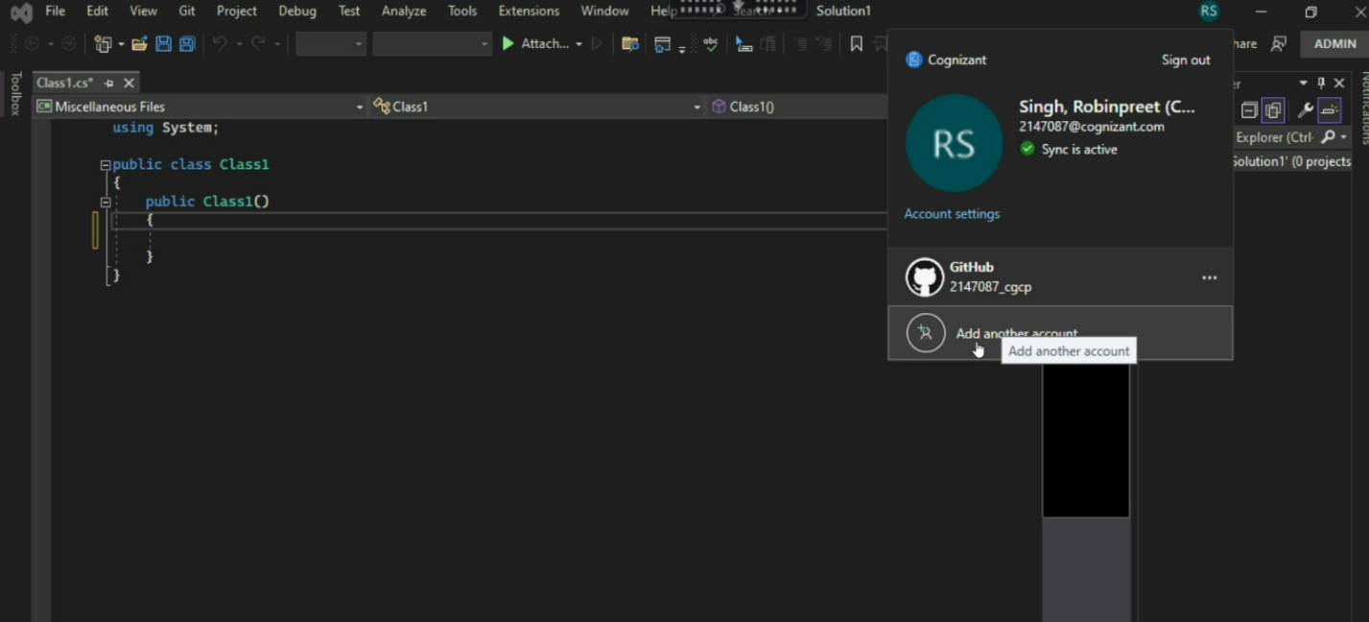

## **GitHub Copilot License fee**

According to Microsoft's official licensing policy, a GitHub license is required to access GitHub CoPilot, which means the regular price is about $20 (GitHub) + $20 (GitHub CoPilot) = $40/Associate/Month. However, until June 2024, Microsoft has offered a special deal that waives the GitHub license fee and reduces the GitHub CoPilot fee, so the current price is only $14/Associate/Month. After June 2024, Microsoft may decide to reinstate the GitHub license fee, which would increase the cost of using GitHub CoPilot.

The screenshot below shows a price of $504, but this is not the amount you will pay. You will only be charged $14 per month for the months that you use the service.

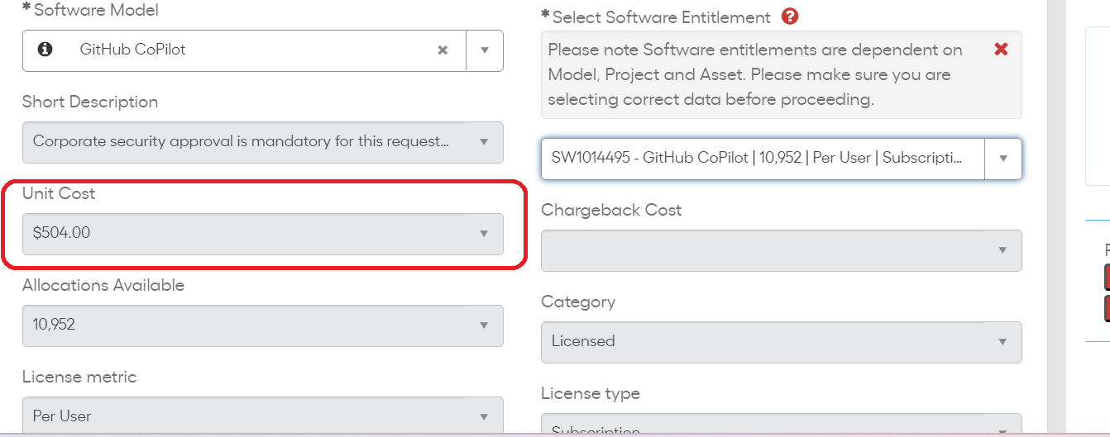

## **Queries through Live Support GSD**

Below queries can be addressed through Service now ticket via Live support GSD process.

|  |  |
| --- | --- |
| **Keywords to raise the Service now ticket** | **Prerequisites** |
| Unable to access Github Copilot | Please make sure you have the below details.  ServiceNow Request ID * : Screen shot of the confirmation from IT infra team on access provision * : |
| License cost details for accessing Github Copilot | Until June 2024, price is only $14/Associate/Month. After June 2024, Microsoft may decide to reinstate the GitHub license fee which would increase the cost of using GitHub CoPilot. Please click  and refer page 6 for more cost related information. [GitHub Copilot request process.docx](https://cognizantonline.sharepoint.com/:w:/r/sites/KHO-AIHub/_layouts/15/doc2.aspx?sourcedoc=%7BBE8621DE-0B4D-45D0-91B0-40E6FE2B88CE%7D&file=GitHub%20Copilot%20request%20process.docx&action=default&mobileredirect=true&ovuser=de08c407-19b9-427d-9fe8-edf254300ca7%2C599868%40cognizant.com&clickparams=eyJBcHBOYW1lIjoiVGVhbXMtRGVza3RvcCIsIkFwcFZlcnNpb24iOiIyNy8yMzExMDIyNDcwNSIsIkhhc0ZlZGVyYXRlZFVzZXIiOmZhbHNlfQ%3D%3D&CID=037DB0AC-A796-4401-B938-3E2E7390A03D&wdLOR=c342090C9-27D2-41AE-A608-128B896C3162) |
| Error while accessing Github Copilot | Please make sure you have the below details.  ServiceNow Request ID * : Screen shot of the confirmation from IT infra team on access provision * : |
| Is our Service line eligible for accessing Github Copilot? | To find the eligible Service Lines, please click  and refer page 4. [GitHub Copilot request process.docx](https://cognizantonline.sharepoint.com/:w:/r/sites/KHO-AIHub/_layouts/15/doc2.aspx?sourcedoc=%7BBE8621DE-0B4D-45D0-91B0-40E6FE2B88CE%7D&file=GitHub%20Copilot%20request%20process.docx&action=default&mobileredirect=true&ovuser=de08c407-19b9-427d-9fe8-edf254300ca7%2C599868%40cognizant.com&clickparams=eyJBcHBOYW1lIjoiVGVhbXMtRGVza3RvcCIsIkFwcFZlcnNpb24iOiIyNy8yMzExMDIyNDcwNSIsIkhhc0ZlZGVyYXRlZFVzZXIiOmZhbHNlfQ%3D%3D&CID=037DB0AC-A796-4401-B938-3E2E7390A03D&wdLOR=c342090C9-27D2-41AE-A608-128B896C3162) |

## **Legal Team - Guidelines**

General guidelines for using GitHub CoPilot from the Legal team for external projects (customer projects).

For project-specific inputs, we require our Account Teams to collaborate with the commercial attorneys for assistance on this matter.

* **Using Copilot for Cognizant Customers:** This is one of the cases of Copilot’s usage where Cognizant BU will use the tool licensed by Cognizant for customer-facing engagements. Considering that there is no need to pass through any specific terms to Cognizant customers, the risks need to be mitigated through internal controls (such as duplicate detection). What we need to be mindful of is that at no point the Copilot will be sublicensed to customers as we do not have that right given by MS. We will also need to verify that we don’t have a contractual obligation to not use Gen AI software before using Copilot.
* **Using Copilot Licensed by Customer:** These are the cases where Cognizant will use Client-provided licenses. Cognizant would need that (1) the Client must procure us a broad license for any third-party software required to perform our Services and (2) the client indemnifies Cognizant for any claims that arise from materials provided by the client.  In this scenario, BU should work with their commercial attorneys so that it can be addressed in the context of the full contractual relationship with the client.

## **Training Video links**

1. GitHub Copilot – K-point session

[https://cognizant.kpoint.com/web/videos/gcc-6fe8aaf5-6b28-46d0-805b-56ce8da1c0d1](https://apc01.safelinks.protection.outlook.com/?url=https%3A%2F%2Fcognizant.kpoint.com%2Fweb%2Fvideos%2Fgcc-6fe8aaf5-6b28-46d0-805b-56ce8da1c0d1&data=05%7C01%7CSunilkumar.P%40cognizant.com%7C9e0babc9acdc40e27eb008dbd62da57e%7Cde08c40719b9427d9fe8edf254300ca7%7C0%7C0%7C638339263759061599%7CUnknown%7CTWFpbGZsb3d8eyJWIjoiMC4wLjAwMDAiLCJQIjoiV2luMzIiLCJBTiI6Ik1haWwiLCJXVCI6Mn0%3D%7C3000%7C%7C%7C&sdata=bNij2z%2FHtYKQC20kHgJ%2Fu62NwFP3FshH1EIWMvrX4tM%3D&reserved=0)

1. Introduction to GitHub (learning + knowledge check)

[Introduction to GitHub Copilot - Training | Microsoft Learn](https://apc01.safelinks.protection.outlook.com/?url=https%3A%2F%2Flearn.microsoft.com%2Fen-us%2Ftraining%2Fmodules%2Fintroduction-to-github-copilot%2F&data=05%7C01%7CSunilkumar.P%40cognizant.com%7C9e0babc9acdc40e27eb008dbd62da57e%7Cde08c40719b9427d9fe8edf254300ca7%7C0%7C0%7C638339263759061599%7CUnknown%7CTWFpbGZsb3d8eyJWIjoiMC4wLjAwMDAiLCJQIjoiV2luMzIiLCJBTiI6Ik1haWwiLCJXVCI6Mn0%3D%7C3000%7C%7C%7C&sdata=xlpsxPFYdhZY%2BYaOLz7y11V%2BsNuuPXIz9TdBGhPMrkM%3D&reserved=0)

1. GitHub Copilot -Visual Studio Toolbox

[Github Copilot | Microsoft Learn](https://apc01.safelinks.protection.outlook.com/?url=https%3A%2F%2Flearn.microsoft.com%2Fen-us%2Fshows%2Fvisual-studio-toolbox%2Fgithub-copilot&data=05%7C01%7CSunilkumar.P%40cognizant.com%7C9e0babc9acdc40e27eb008dbd62da57e%7Cde08c40719b9427d9fe8edf254300ca7%7C0%7C0%7C638339263759061599%7CUnknown%7CTWFpbGZsb3d8eyJWIjoiMC4wLjAwMDAiLCJQIjoiV2luMzIiLCJBTiI6Ik1haWwiLCJXVCI6Mn0%3D%7C3000%7C%7C%7C&sdata=%2F%2BE9zE%2FD%2BHRxDfsZLzEP9fKUXk%2F44qwytj4zUV%2Bn%2Fvs%3D&reserved=0)

1. GitHub Copilot Series - YouTube

<https://www.youtube.com/playlist?list=PLj6YeMhvp2S5_hvBl2SE-7YCHYlLQ0bPt>